Revision Exercise: Section D Part 1 - ANSWERS
In Section D you will work with JASP. It has two parts (in separate revision documents here).
For Part 1, you need to create new data and variables in a blank JASP sheet.

Part 1
1. You will be asked to open a ‘new data’ page in JASP
2. You will be asked to create some variables, by adding values into the columns.
- Make sure you add them correctly, in the same order as presented

For this exercise, you are the researcher who wants to explore whether cups of coffee per day relate to productivity score (0 - 100 scale).
Enter these two variables, add the following values (in the same order it is presented) into each column:
Column 1: 0, 1, 2, 3, 4, 5, 6
Column 2: 81, 62, 70, 55, 68, 81, 90

If you are asked to provide a screenshot this at this stage, it should look like this:
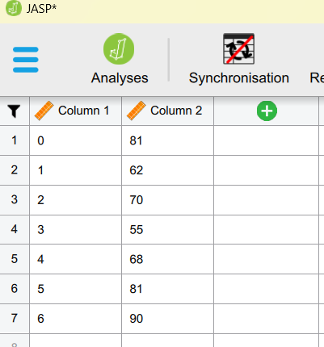
3. You may then be asked to edit your variables.
For example, changing the type of data (using the icon) or to rename them.
For this exercise, rename Column 1 variable to “CoffeeDrank”, and the Column 2 variable as “Productivity”.

If you are asked to provide a screenshot this at this stage, it should look like this:
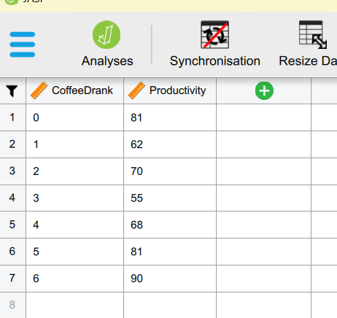

SCREENSHOT advice:
- Note the size of my screenshots and what I’ve included?
- I’ve only included the relevant information and the partial screen – not the whole JASP screen.
- I use the Print Screen shortcut key (Prt Scr) on Windows to select the area then just hit Ctrl + P for paste!
- When I pasted it in – it was too big! So I just used the little resize dots to make it smaller.

4. You may be asked to calculate and present some descriptives data using JASP
For example, specific types of measures of central tendency or measures of dispersion.
You may be asked to create a Figure or a Table, or to write it up in APA format in text.

For this exercise, create a Descriptives table to show only the following information for the Coffee and Productivity variables:
- Mean
- Variance

Note: there isn’t an APA requirement mentioned in the question. But certain measures are specifically requested – so make sure you follow it. Since this is a table, you can copy/paste it directly from JASP or take a screenshot.

This is correct because it only includes Mean and Variance: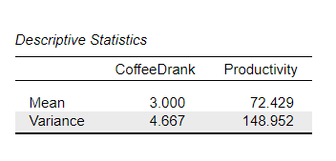
This is incorrect because it includes a lot of measures that weren’t required:
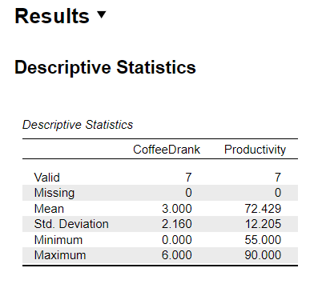

5. You may be asked to run specific assumption checks on your new variables
For example, the assumption may be mentioned by name directly or may require you to identify the type of assumption from the information provided.
You may be asked to paste the assumption test output directly from JASP as a table (e.g. screenshot or copy/paste) or to write up the result (in APA style).

For this exercise, check that both variables meet the assumption of normality. Write down the assumption test results in APA format.
For this, you will need to write a short sentence for each variable for example:
The data for number of Coffees drunk was normally distributed (W = .978, p = .949), and the Productivity scores also met the assumption of normality (W = .967, p = .878).

Note the APA formatting – the decimal places, no leading zeros, and the Italics!

Or the question on assumptions could ask about another assumption and require a Figure, for example:
For this exercise, check both variables for outliers. Evidence the most appropriate way of checking for outliers in your data. You should interpret the result – stating whether there are outliers, and what you would do with them (i.e., remove or keep in).

So here, we’re looking for you to paste two figures – boxplots in JASP and to have ticked ‘label outliers’ to identify any outliers. And we’re looking for you to confirm that there are no outliers for either variable.
